1. **Gantt Chart**

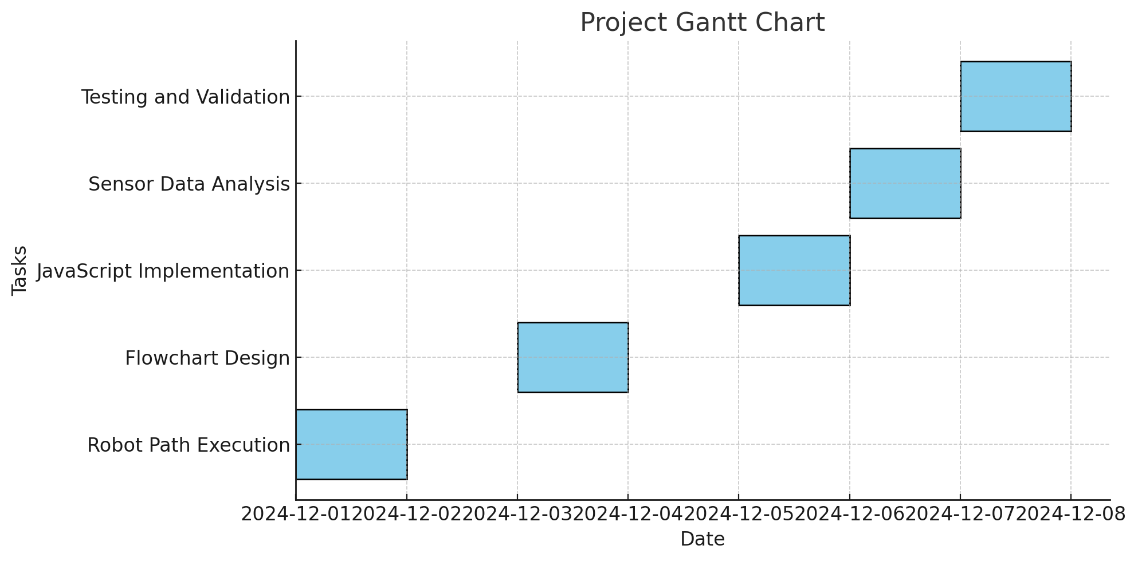

1. **Requirements Table**

| **Requirement ID** | **Description** | **Status** |
| --- | --- | --- |
| R1 | Robot must follow path without hitting obstacles and knock down all markers | Complete |
| R2 | Flowchart must match the algorithm steps | Complete |
| R3 | Javascript code must drive the Sphero Bolt | Complete |
| R4 | Sensor data must be collected and analyzed | Complete |

1. **Requirments Signoff Table**

| **Requirement ID** | **Signoff By** | **Date** |
| --- | --- | --- |
| R1 | Isaac and Bilal | 12/6/24 |
| R2 | Isaac and Bilal | 12/6/24 |
| R3 | Isaac and Bilal | 12/6/24 |
| R4 | Isaac and Bilal | 12/6/24 |

1. **Algorithm**
2. Start the program.
3. Call roll(0°, 255, 0.85) and wait for completion.
4. Delay for 2 seconds.
5. Call roll(90°, 255, 1) and wait for completion.
6. Delay for 2 seconds.
7. Call roll(0°, 255, 1.05) and wait for completion.
8. Delay for 2 seconds.
9. Call roll(90°, 255, 2) and wait for completion.
10. Delay for 2 seconds.
11. Call roll(225°, 255, 2) and wait for completion.
12. Delay for 2 seconds.
13. Set motor control directly:
14. Left motor to 0
15. Right motor to 255
16. Duration to 10 seconds
17. Delay for 2 seconds.
18. End the program.
19. **Flowchart**

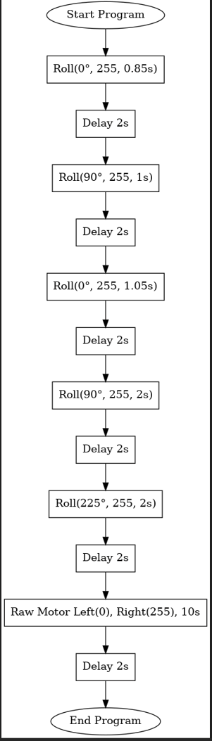

1. **Block Code**

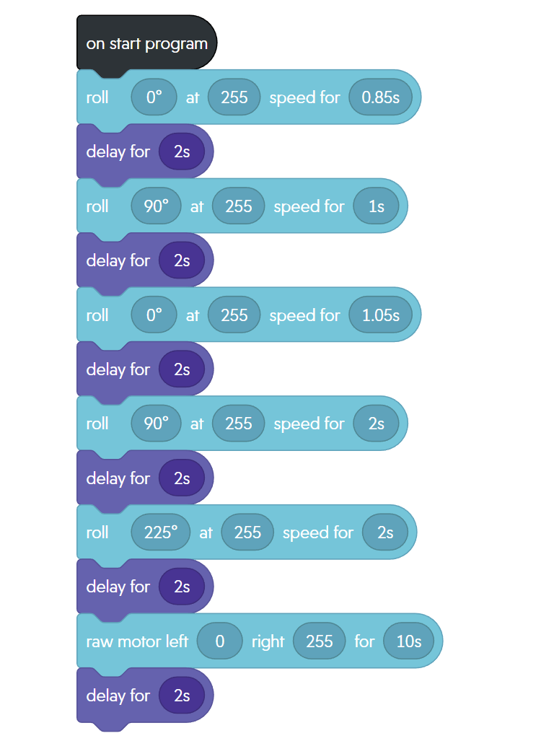

1. **Sensor Data**

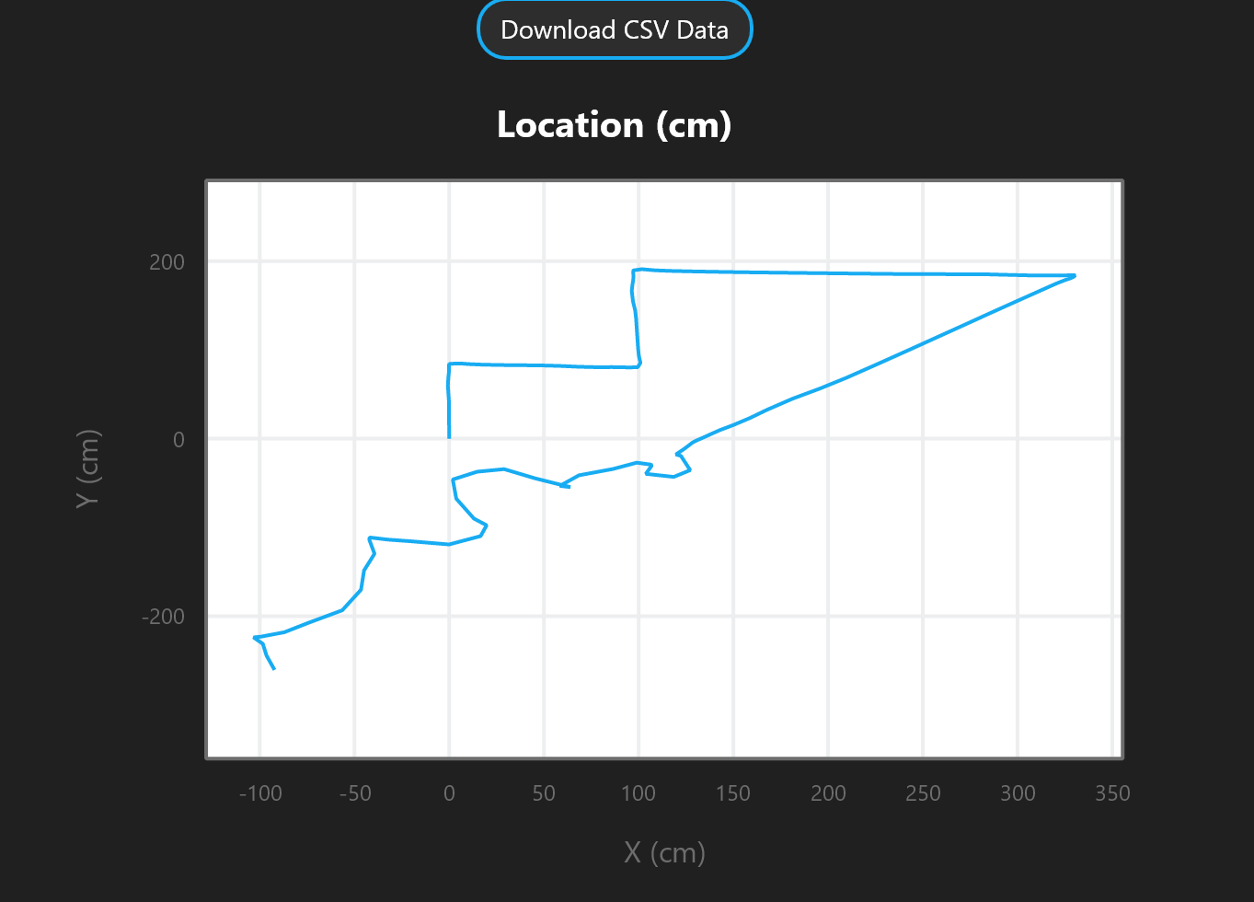

1. **Test Table**

| **Test Case** | **Description** | **Expected Outcome** | **Actual Outcome** | **Pass/Fail** |
| --- | --- | --- | --- | --- |
| TC1 | Folow path, avoid obstacles, go up ramp | Robot follows path and goes up ramp | Robot somewhat followed path and went up the ramp well | Pass |
| TC2 | Knock down all markers | Knocks all markers down first try | Took a little moving around to get them all knocked down | Pass |

1. **Staffing Plan**

| **Name** | **Title** | **Responsibilities** |
| --- | --- | --- |
| Isaac Sasson | Group leader | Submit project and create github |
| Bilal Shweb | Group member | Assist with the project and github |